Lola's Horchata
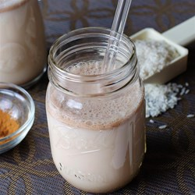
- Prep:10 m
- Ready In: 3 h 10 m
Recipe By: LOLA
"A very easy way to make great horchata!"
Ingredients
- 1 cup uncooked white long-grain rice
- 5 cups water
- 1/2 cup milk

- 1/2 tablespoon vanilla extract
- 1/2 tablespoon ground cinnamon
- 2/3 cup white sugar
Directions
- Pour the rice and water into the bowl of a blender; blend until the rice just begins to break up, about 1 minute. Let rice and water stand at room temperature for a minimum of 3 hours.
- Strain the rice water into a pitcher and discard the rice. Stir the milk, vanilla, cinnamon, and sugar into the rice water. Chill and stir before serving over ice.

http://allrecipes.com/recipe/141828/lolas-horchata/
Aaron Sanchez's Mexican Brownies
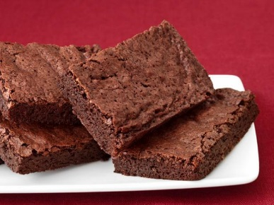
Ingredients
- 2 sticks unsalted butter, plus more for greasing
- 2 cups sugar
- 4 large eggs
- 2 teaspoons vanilla extract
- 2/3 cup good-quality unsweetened cocoa powder
- 1 cup all-purpose flour
- 1 teaspoon ground Mexican cinnamon (canela)
- 1/4 teaspoon pequen chili powder or cayenne pepper
- 1/2 teaspoon kosher salt
- 1/2 teaspoon baking powder

Directions
Preheat the oven to 350 degrees. Line a 9-by-13-inch baking dish with parchment paper, leaving an overhang on two sides. Press the paper into the corners of the pan and lightly grease the paper with butter.
Melt the 2 sticks of butter in a nonstick saucepan over medium-low heat; do not boil. Remove from the heat and let cool slightly. Add the sugar, eggs and vanilla to the saucepan and stir with a wooden spoon until combined.
Add the cocoa, flour, cinnamon, chili powder, salt and baking powder and mix until smooth. Spread the batter in the prepared pan and bake until a toothpick inserted in the middle comes out fudgy, 20 to 25 minutes. Cool in the pan on a rack, then use the parchment paper to lift out the brownies before slicing.
Photograph by Kate Sears
Recipe courtesy Aaron Sanchez for Food Network Magazine
http://www.foodnetwork.com/recipes/aaron-sanchez/aaron-sanchezs-mexican-brownies-recipe

Mexican Salsa Recipe
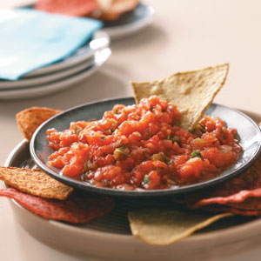

TOTAL TIME: Prep: 40 min.YIELD:14 servings
Ingredients
- 3 jalapeno peppers
- 1 medium onion, quartered
- 1 garlic clove, halved
- 2 cans (one 28 ounces, one 14-1/2 ounces) whole tomatoes, drained
- 4 fresh cilantro sprigs
- 1/2 teaspoon salt
- Tortilla chips
Directions
- 1. Heat a small ungreased cast-iron skillet over high heat. With a small sharp knife, pierce jalapenos; add to hot skillet. Cook for 15-20 minutes or until peppers are blistered and blackened, turning occasionally.
- 2. Immediately place jalapenos in a small bowl; cover and let stand for 20 minutes. Peel off and discard charred skins. Remove stems and seeds.
- 3. Place onion and garlic in a food processor; cover and pulse four times. Add the tomatoes, cilantro, salt and jalapenos. Cover and process until desired consistency. Chill until serving. Serve with chips. Yield: 3-1/2 cups.
http://www.tasteofhome.com/recipes/mexican-salsa

Easy Pico de Gallo Recipe
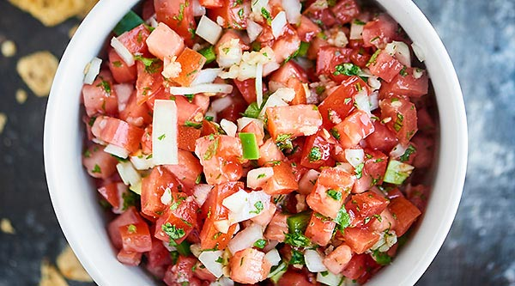

This Easy Pico de Gallo Recipe comes together in a matter of minutes! Fresh tomatoes, onion, cilantro, jalapeno, lime, & garlic make this truly delicious.
Servings  2-3 people | Prep Time  10 minutes

Ingredients
- 5 roma tomatoes diced
- 1/4 yellow onion diced
- 1/4 cup Cilantro minced
- 1/2 jalapeno pepper minced, seeded if you want a more mild taste
- 2 tablespoons freshly squeezed lime juice
- 2 cloves garlic minced or pressed
- salt to taste
Instructions
- Place all ingredients into a large bowl.
- Mix and season with salt, to taste.
- Cover and place in fridge until ready to serve!

http://showmetheyummy.com/easy-pico-de-gallo-recipe/

Easy Homemade Guacamole Recipe
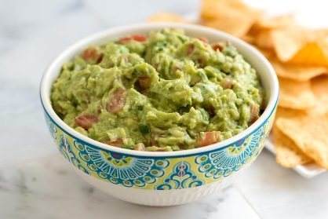
- PREP 10mins
- TOTAL 10mins
For the best guacamole, you will need ripe avocados. You’ll know when an avocado is ripe when it gives just slightly when squeezed. Keep unripe avocados at room temperature until they are ready. Try not to over mash or puree avocados when making guacamole. You want a chunky avocado dip, not smooth.
Makes approximately 6 servings
YOU WILL NEED
1/4 cup finely minced onion
3 ripe Haas avocados
1 1/2 tablespoons fresh lime juice (or lemon juice)
1 large Plum or Roma tomato, deseeded and diced
1/4 cup cilantro leaves and tender stems, chopped
1/2 teaspoon ground cumin
1/2 teaspoon salt, or more to taste
1 to 2 teaspoons minced jalapeño or Serrano pepper, optional
DIRECTIONS
Add diced onion to a small bowl then cover with warm water, set aside. This “de-flames” the onions, making them less intense.
Cut avocados in half, lengthwise and use a spoon to scoop out the seed. Scoop out the flesh and add to a bowl.
Add lime juice then use a fork to gently mash until creamy, but still chunky. Stir in the tomato, cilantro, cumin, salt and diced peppers (if using). Taste the guacamole and adjust with additional salt, peppers, or lime juice.
Serve immediately or cover with plastic wrap by pushing the plastic wrap down onto the guacamole and refrigerate up to one day.
http://www.inspiredtaste.net/20172/our-favorite-guacamole-recipe-with-video/

