Collège Churchill
English – Grade 7

Teacher: Mme Zacharias
Email: mzacharias@wsd1.org
Website : mmezacharias.weebly.com

Course Description
Welcome to Grade 7 English!!
Our focuses this year are listed on the chart below:

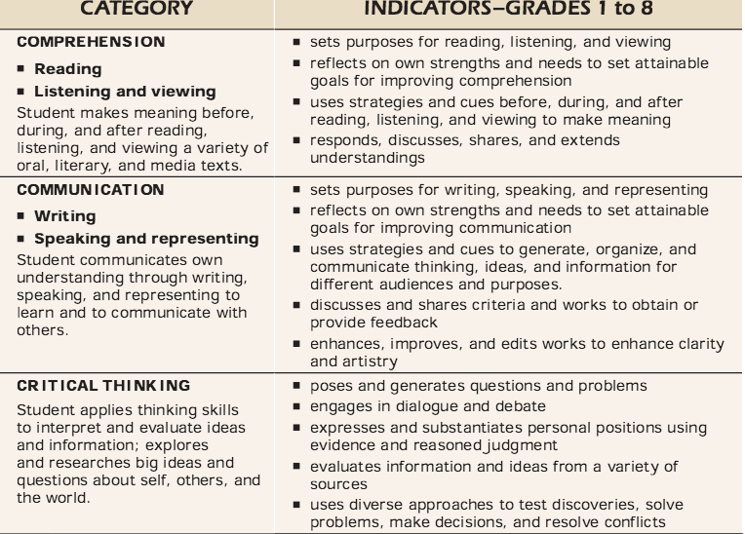

The development of these important literary skills is not only important to achieving success in the Language Arts classroom, it is a critical component of achieving success in other school subjects, building strong relationships with others, and attaining a flourishing career as an adult. Basically, the quality of life you experience now through adulthood will depend a lot on how well you read, write, and communicate with others.

Marks
Assignments/Projects = 35%
Tests/Quizzes = 45%
Final Exam = 20%

Classroom Rules
Appropriate behaviour is mandatory in the classroom to assure that everyone has a great learning environment. To achieve this, everyone must abide by the following social values:
- Acceptance
- Respect
- Cooperation
- Honesty
- Compassion
- Responsibility

Code of Conduct
- We will be polite and respectful towards others at all times.
- We will be responsible.
- We will work quietly and not disturb others.
- We will be honest and trustworthy.
- We will respect our teacher and other adults.
- We will be prepared for class every day.
- We will arrive to class on time.
- We will make smart choices.
- We will cooperate with others.
10. We will always do our best.

If a student breaks the Code of Conduct there will be certain consequences for the breach. The following will take place in order each time the Code of Conduct is broken:

- A verbal warning (extra homework may also be given depending on the situation)
- An individual meeting with Mme Zacharias
- Parents will be notified via telephone call

Please do not break the Code of Conduct so that consequences will not take place.

Celulares - Cell Phones
Please do NOT bring your cell phone to the classroom unless Mme Zacharias has asked you prior to bring them for educational purposes. Please keep your cell phone in your locker or at the front in the “cell phone box”.

Comida - Food
NO FOOD OR DRINKS IN CLASS PLEASE!

FAQ
- What do I do if I am absent from class?
There will be a “While I was Away” file bin in the classroom where you can find worksheets and assignments that you have missed while you were away. You can also ask a classmate or ask Mme Zacharias for any other questions you might have while you were absent. It is the student’s responsibility to make sure they are up-to-date and hand in all their assignments on time in Spanish class.

- How do I know if there is homework?
There will be a “Homework” board in the classroom that states all homework and the assigned due date. It is the student’s responsibility to make sure all work assigned is handed in on time. Students can also visit the class website to get any class material they may need. It is the student’s responsibility to make sure they are up-to-date and hand in all their assignments on time in Spanish class.

If you have any other questions please do not hesitate to ask Mme Zacharias.

Students:
Please sign and date below to signify that you have read the course sheet for Mme. Zacharias’ class, will keep it in your binder, and will be responsible for the information throughout the year.

Student printed name Student signature

Date

Parents/Guardians:
Please sign and date below to indicate that you have read the course sheet for Mme. Zacharias’ class and that you will help your student be accountable for the information. If you have questions about the course or your student’s work, please do not hesitate to contact me

Parent/Guardian printed name Parent/Guardian signature

Date

Please return signed part to Mme Zacharias by Friday, September 9th.

